[COVER PAGE]

# TABLE OF CONTENTS

TABLE OF CONTENTS 2

EXECUTIVE SUMMARY 4

INTRODUCTION 5

SITE LOCATION 5

STUDY PURPOSE 5

WATERSHED DESCRIPTION 6

DELINEATION 6

SOIL PROPERTIES 7

DESIGN RISK LEVEL 11

DESIGN STORMS 14

X-YR, 24-HR SCS TYPE-2 14

X -YR, 24-HR TXHYETO(50%) 15

X-YR, 6-HR SCS 17

X-YR, 6-HR TXHYETO(50%) 20

HEC-HMS CONCEPTUALIZATION 21

RAINFALL RUNOFF MODEL 23

LOSS MODEL 23

UNIT HYDROGRAPH MODEL 25

HYDROGRAPH ROUTING ELEMENTS 28

CHANNEL ELEMENTS 28

RESERVOIR STORAGE ELEMENTS 30

NORTH RESERVOIR ELEVATION-AREA-STORAGE TABLE 30

WEST RESERVOIR ELEVATION-AREA-STORAGE TABLE 30

US-87 RESERVOIR ELEVATION-AREA-STORAGE TABLE 31

DISCHARGE ESTIMATES 32

PEAK WATER SURFACE ELEVATION 32

EXISTING CONDITION 32

PROPOSED CONDITION 32

INTERPRETATION OF RESULTS 33

SUMMARY, CONCLUSIONS, AND RECOMMENDATIONS 34

REFERENCES 35

APPENDIX-I MANNING’S N VALUES 36

APPENDIX-II HEC-HMS Support Files (Excel Spreadsheets) 38

# LIST OF TABLES

Table 1. Drainage Areas for Harden Creek Watershed Study Area 7

Table 2. Drainage Path Distances for Harden Creek Watershed Study Area 7

Table 3. Soil Properties for Harden Creek Study Area 9

Table 4. CAPTION THE TABLE 24

Table 5. CAPTION THE TABLE 27

# LIST OF FIGURES

Figure 1. Culvert system located approximately 1/2 mile West of Eden, Texas. 5

Figure 2. Caption The Figure 6

Figure 3. WSS Map of the Study Area. 8

Figure 4. Existing Crossing Configuration 10

Figure 5. Here is the proposed -- you draw the 4-barrel system. 10

Figure 6. CAPTION THE FIGURE 12

Figure 7. CAPTION THE FIGURE 13

Figure 8. CAPTION THE FIGURE 11

Figure 9. X-YR, 24-HR Texas DDF Map. The COLOR shaded area is Concho County, Texas. 14

Figure 10. X-YR, 24-HR SCS Type 2 Design Storm for Concho County, Texas. 15

Figure 11. X-YR, 24-HR TXHYETO-2015.xlsm Design Storm for Concho County, Texas. 16

Figure 12. X-YR, 24-HR Design Storm (HEC-HMS) for Concho County, Texas. 17

Figure 13. X-YR, 6-HR Texas DDF Map. The COLOR shaded area is Concho County, Texas. 18

Figure 14. X-YR, 6-HR SCS Design Storm (HEC-HMS) for Concho County, Texas. 19

Figure 15. X-YR, 24-HR TXHYETO-2015.xlsm Design Storm for Concho County, Texas. 20

Figure 16. X-YR, 24-HR Design Storm (HEC-HMS) for Concho County, Texas. 21

Figure 17. CAPTION THE FIGURE 22

Figure 18. CAPTION THE FIGURE 23

Figure 19. NRCS lag time analysis for West Catchment. 26

Figure 20. NRCS lag time analysis for North Catchment. 26

Figure 21. NRCS lag time analysis for Eden Catchment. 27

Figure 22. Typical Cross Section for <name 1>. 28

Figure 23. Typical Cross Section for <name 2>. 28

Figure 24. Typical Cross Section for <name 3>. 29

Figure 25. CAPTION THE FIGURE 30

Figure 26. CAPTION THE FIGURE 31

# EXECUTIVE SUMMARY

Add Narrative Here – the executive summary is usually written last, however except for results, you can write most of it using the skeleton report here

# INTRODUCTION

<Add Narrative Here>

## SITE LOCATION

Figure 1 is a map of a portion of Concho County, Texas. In the Southeast corner of the map is Eden, Texas. A US highway runs nearly East-West through Eden and another US highway runs North-South.

The location of interest is a culvert system located about ½ mile West of the intersection of US 84 and US 87 in Eden, Texas.

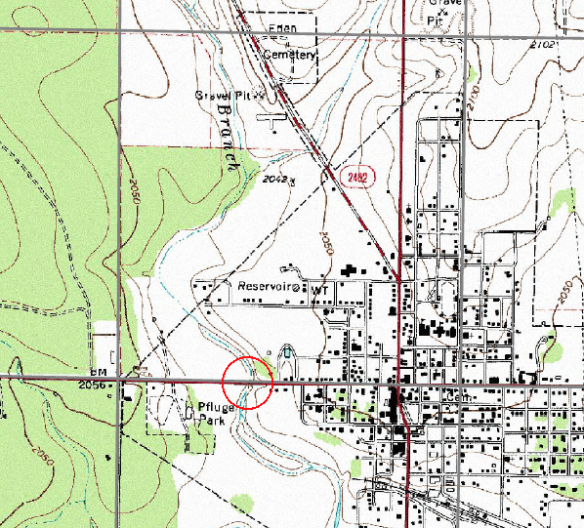

Figure 1. Culvert system located approximately 1/2 mile West of Eden, Texas.

## STUDY PURPOSE

The existing culvert system is a 2-barrel 6X6 box-culvert system. This report presents an hydrologic analysis of the existing system at an appropriate risk level to determine the depth of water at the structure (or overtopping depth), and a determination of the depth of flow if the culvert system is modified by the addition of two more barrels to a total of 4-barrel 6X6 box-culvert system.

# WATERSHED DESCRIPTION

<Brief overview of the watershed as it pertains to the study – details are presented in sub-sections that follow>

## DELINEATION

Figure 2 is the watershed that contributes flow to the crossing structure. The total contributing area is 16.82 square miles. Two SCS reservoirs regulate flow in the upper reach of the watershed. The sub-areas regulated by these two reservoirs are called the West Catchment, and the North Catchment. The contributing area downstream of both reservoir outlets, but upstream of the point of interest is called the Eden Catchment.

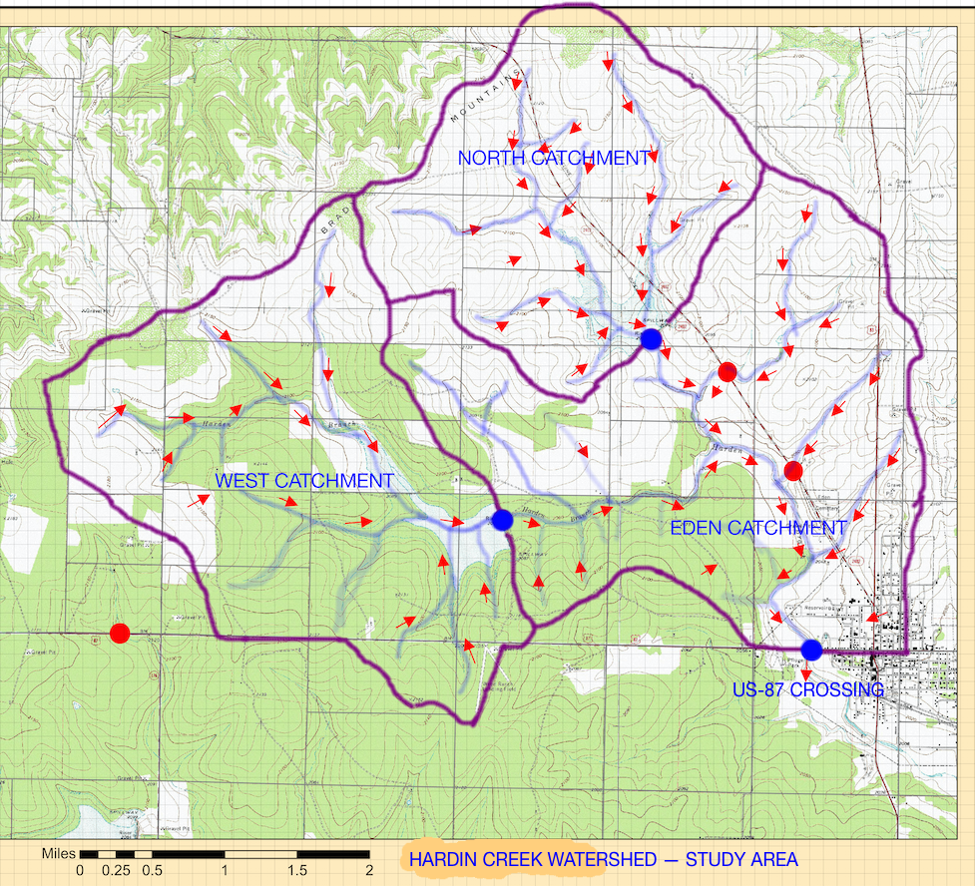

Figure 2. Hardin Creek Watershed Study Area

The watershed was delineated using the method described in McCuen, 1989; pp. 100-106. Table 1 is a list of the individual sub-catchment areas.

Table 1. Drainage Areas for Hardin Creek Watershed Study Area

|  |  |  |
| --- | --- | --- |
| Description | Value | Units |
| North Catchment | 3.83 | Square miles |
| West Catchment | 6.04 | Square miles |
| Eden Catchment | 6.95 | Square miles |
| Total Drainage Area | 16.82 | Square miles |

The watershed delineation map in Figure 2 was also employed to estimate the travel (channel) distances for each (sub) catchment. The distances were estimated using manual opisometry (measuring length of arbitrary curved paths) as described in USAF 1985 pp. 322-326. These distances are used below to estimate time-of-concentration values to parameterize unit hydrographs for each (sub) catchment, and to estimate Muskingum-Cunge parameters for channel routing.

Table 2 is a list of the channel length segments for each catchment. For example, the channel length for the West Catchment to the Reservoir Outlet was estimated to be 3.44 miles. The channel length for the West Catchment Reservoir Outlet to the US-87 crossing was estimated to be 3.62 miles.

Table 2. Drainage Path Distances for Hardin Creek Watershed Study Area

|  |  |  |
| --- | --- | --- |
| Item | Value | Units |
| North Catchment to Reservoir Outlet | ~2.74 | Miles |
| West Catchment to Reservoir Outlet | ~3.44 | Miles |
| Eden Catchment to US 87 Crossing | ~3.69 | Miles |
| West Reservoir Outlet to US 87 Crossing | ~3.62 | Miles |
| North Reservoir Outlet to US 87 Crossing | ~2.99 | Miles |

## SOIL PROPERTIES

The USDA-ARS Web Soil Survey was used to estimate the soil properties for the study area, in particular the major soil textural descriptions and infiltration rate, both of which are used to determine a curve number. Figure 3 is a screen capture of the relevant portion of the Web Soil Survey (USDA-NRCS, 2016) map for the study area.

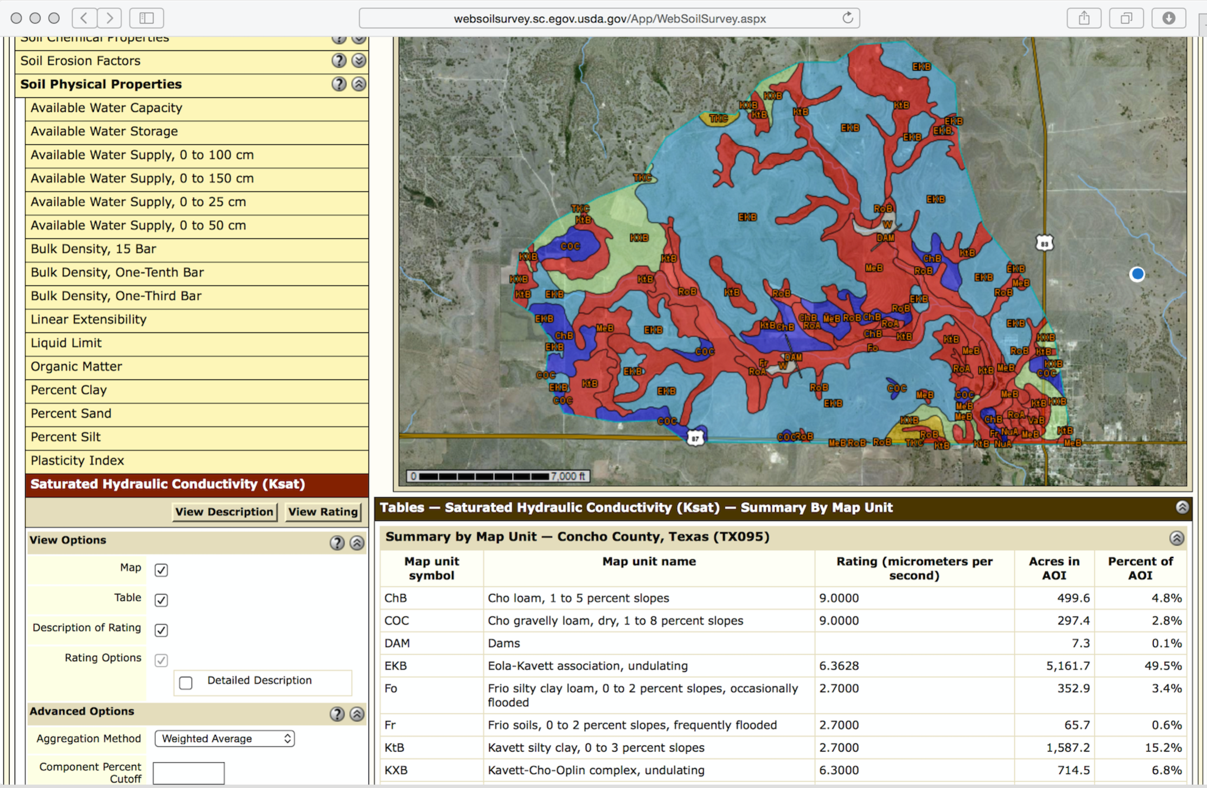

Figure 3. Web Soil Survey, Soils Properties Map of the Study Area.

The table depicted in Figure 3 is presented in its entirety below as Table 3, which is a listing of soil texture, fraction of total area, and saturated hydraulic conductivity in microns per second.

The saturated hydraulic conductivity (Ksat) refers to the ease with which pores in a saturated soil transmit water. The estimates are expressed in terms of micrometers per second. They are based on soil characteristics observed in the field, particularly structure, porosity, and texture. Saturated hydraulic conductivity is considered in the design of soil drainage systems and septic tank absorption fields.

For each soil layer, this attribute is actually recorded as three separate values in the database. A low value and a high value indicate the range of this attribute for the soil component. A "representative" value indicates the expected value of this attribute for the component. For this soil property, only the representative value is used.

The standard Ksat class limits are:

Very low: 0.00 to 0.01;

Low: 0.01 to 0.1;

Moderately low: 0.1 to 1.0;

Moderately high: 1 to 10;

High: 10 to 100;

Very high: 100 to 705.

The properties for this study are in the Moderately High category. Numerically approximately 65% of the study area has a Ksat of 0.106 inches/hour (9 m/sec) and the remaining 35% of the study area has a Ksat of 0.032 inches/hour (2.7 m/sec).

Table 3. Soil Properties for Harden Creek Study Area

|  |  |  |  |  |
| --- | --- | --- | --- | --- |
| Summary by Map Unit — Concho County, Texas (TX095) | | | | |
| Map unit symbol | Map unit name | Ksat | Acres in AOI | Percent of AOI |
| ChB | Cho loam, 1 to 5 percent slopes | 9.0 | 601.0 | 5.4% |
| COC | Cho gravelly loam, dry, 1 to 8 percent slopes | 9.0 | 555.4 | 5.0% |
| EKB | Eola-Kavett association, undulating | 9.0 | 5,388.0 | 48.7% |
| Fo | Frio silty clay loam, 0 to 2 percent slopes, occasionally flooded | 2.7 | 350.2 | 3.2% |
| Fr | Frio soils, 0 to 2 percent slopes, frequently flooded | 2.7 | 64.9 | 0.6% |
| KtB | Kavett silty clay, 0 to 3 percent slopes | 2.7 | 1,530.5 | 13.8% |
| KXB | Kavett-Cho-Oplin complex, undulating | 2.7 | 684.5 | 6.2% |
| MeB | Mereta clay loam, 1 to 3 percent slopes | 2.7 | 735.2 | 6.6% |
| NuA | Nuvalde silty clay loam, 0 to 1 percent slopes | 2.7 | 11.3 | 0.1% |
| RoA | Rowena clay loam, 0 to 1 percent slopes | 2.7 | 147.9 | 1.3% |
| RoB | Rowena clay loam, 1 to 3 percent slopes | 2.7 | 834.8 | 7.5% |
| TKC | Tarrant-Oplin-Kavett association, undulating | 2.7 | 72.3 | 0.7% |
| VaB | Valera silty clay, 0 to 3 percent slopes | 2.7 | 18.4 | 0.2% |
| ChB | Cho loam, 1 to 5 percent slopes | 9.0 | 601.0 | 5.4% |
|  | Totals for Area of Interest |  | 11,063.3 | 100.0% |

An area weighted mean value is a Ksat of 0.08 inches/hour (6.8 m/sec). This value will be used to represent the area and estimate a meaningful curve number from the National Engineering Handbook Chapter 630 (cite).

EXISTING CROSSING CONFIGURATION

Figure 4 is a sketch of the existing crossing hydraulic structure comprised of 2 6X6 concrete box culverts laid on the channel bottom, with backfill material supporting the roadway. The road profile is approximated in this study as a notched weir, approximately 660 feet wide, with a crest at elevation 2020 feet. The culvert invert elevations (flow line) are at elevation 2010 feet. The backfill and the roadway deck is assumed to be roughly 4 feet thick. That is the 6 foot rise + 4 foot fill and deck = 10 feet total elevation above the drainage channel.

# 

Figure 4. Existing Crossing Configuration

Figure 5 is the alternate configuration where two additional 6X6 concrete culverts are added to the existing configuration. The weir width and notch height are depicted on the figure.

# 

Figure 5. Alternative Crossing Configuration (4-barrel culvert system).

The other properties (crest and invert elevations) are unchanged for the alternate hydraulic structure.

HYDROLOGIC ANALYSIS

<Brief overview of this section. Details in the following subsections.>

## DESIGN RISK LEVEL

The design risk level (ARI for estimating rainfall and subsequent discharge at the water crossing) was determined using Table 4-2 from the TxDOT Hydraulic Design Manual (CITE) in conjunction with the Statewide Planning Map (CITE).

The statewide planning map is used to determine the functional classification of the highway in the vicinity of the hydraulic structure. Table 4-2 is then consulted to determine the recommended design frequency.

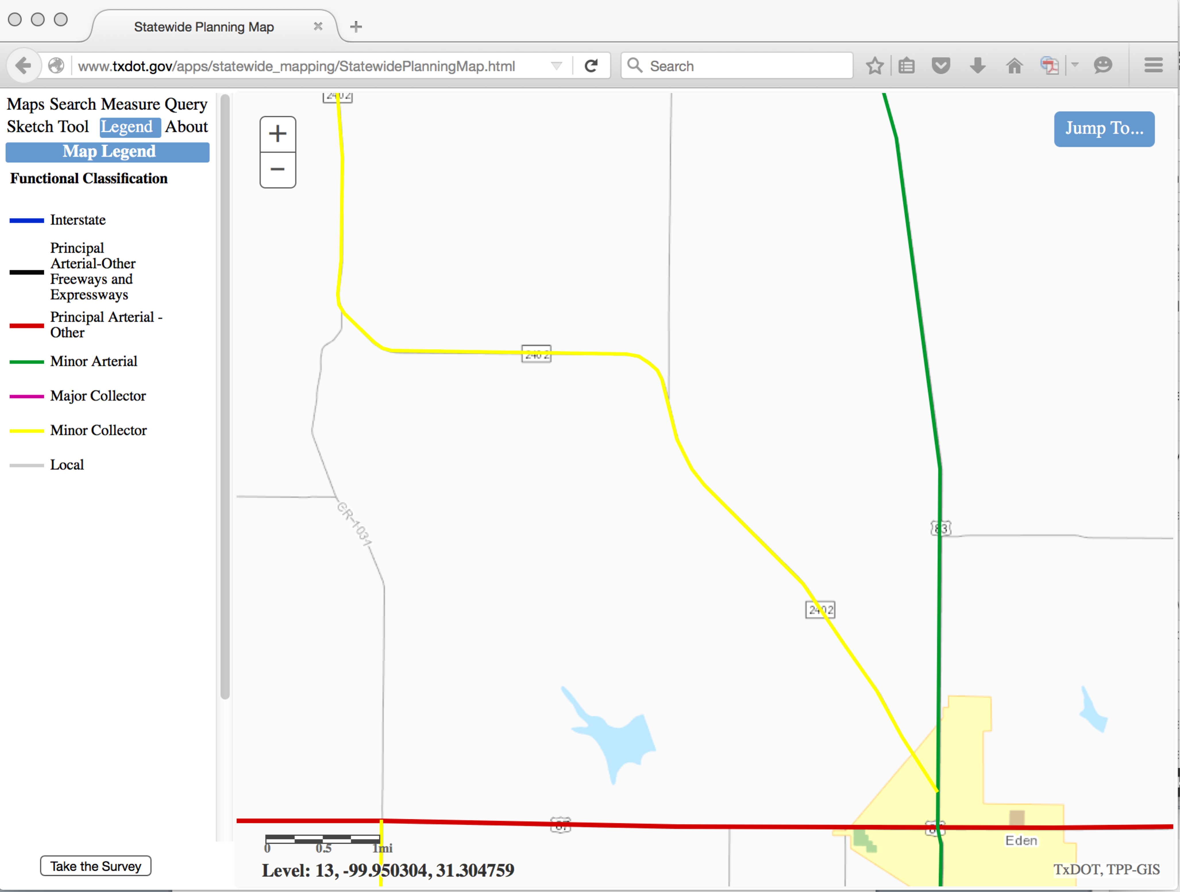

Figure 6. Statewide Planning Map in Vicinity of Hardin Creek – US87 crossing. The functional classification of the highway is “Principal Arterial – Other”

Figure 6 is a screen capture of the relevant portion of the statewide planning map. From the figure and its legend, the functional classification of US 87 in the vicinity of the water crossing is “Principal Arterial – Other.”

Table 4-2 from the TxDOT Hydraulic Design Manual (cite) is reproduced below as Figures 7 and 8.



Figure 7. Design AEP/ARI Standards from TxDOT (cite) (Page 1 of 2)

Figures 7 above shows the intersection of the functional classification, hydraulic structure type and the recommended AEP/ARI (4%/25-year).

The relevant portions of Figure 8 are highlighted. The requirement that all facilities should be evaluated for the 1% AEP (100-yr ARI) to establish where flooding may occur when such an event occurs will also be applied in this study.



Figure 8. Design AEP/ARI Standards from TxDOT (cite) (Page 2 of 2)

## DESIGN STORMS

The risk level determined above was used to create several design storms for estimating the hydrologic and hydraulic performance of the US-87 culvert system. Multiple storm types were examined because the watershed system is too large for application of the Rational Method, and the critical storm duration was unknown a-priori. The watershed is about 16 square miles and the response time based on a rule-of-thumb (CITE) is about 4 hours. A 6-hour storm was selected because the 6-hr SCS storm could be investigated along with various Texas-specific storms.

### 25-YR, 24-HR SCS TYPE-2

The 25-yr, 24-hr SCS Type 2 was selected as one of the design storms to evaluate the US-87 crossing.

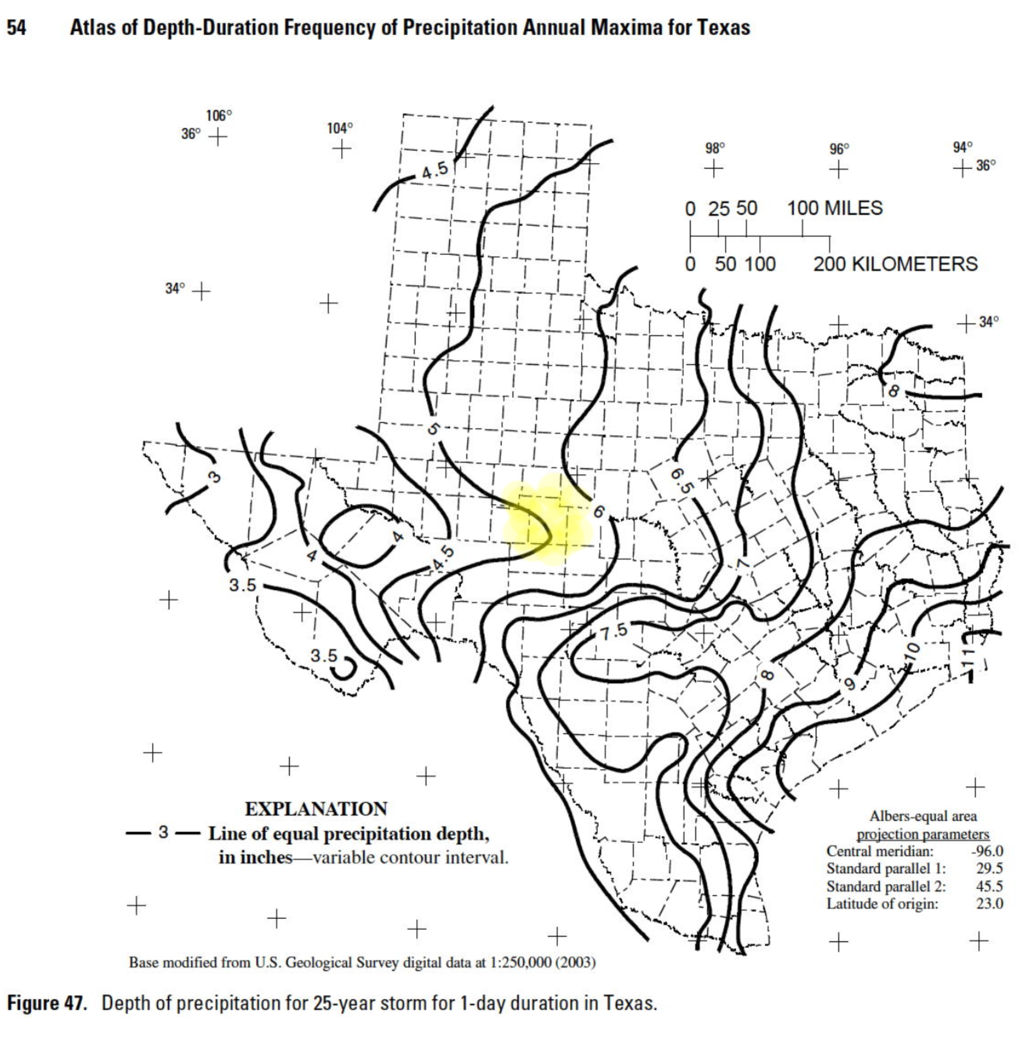

Figure 9. 25-YR, 24-HR Texas DDF Map. Concho County is the shaded area.

The total storm depth was determined using the Texas DDF Atlas (Asquith and Roussel, 2004) for Concho County. Figure 9 is the relevant map from the DDF Atlas; Concho County is the yellow shaded area shown in Figure 6. The 25-yr, 24-hr storm depth from the map is approximately 5.0 inches.

The depth from the Texas DDF map was entered into HEC-HMS to generate an SCS Type 2 Design Storm. Figure 10 is a plot of the SCS Storm for Concho County. The peak precipitation rate, in inches-per-hour is 2.14 inches/hour. The peak rate occurs at an elapsed time of 12 hours.

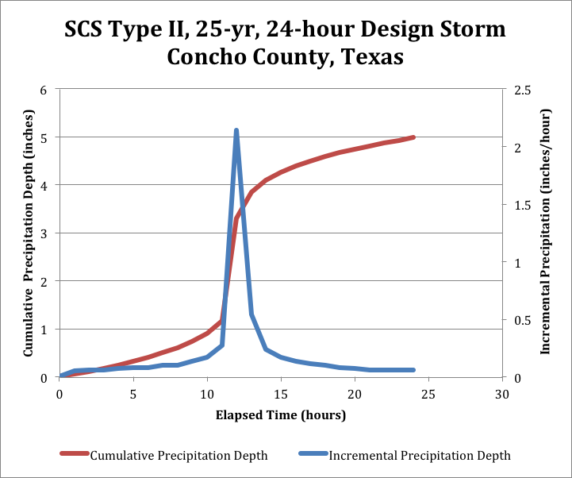

Figure 10. 25-YR, 24-HR SCS Type 2 Design Storm for   
Concho County, Texas.

### 25 -YR, 24-HR TXHYETO(50%)

The 25-yr, 24-hr storm depth from the DDF Atlas was also used to parameterize the Texas Hydrograph using the TXHYETO-2015 tool (Neale, et. al. 2015). The 50th-percentile dimensionless hyetograph was chosen and parameterized for 60-minute time intervals for use in HEC-HMS as an alternative storm to evaluate the performance of the hydraulic structures.

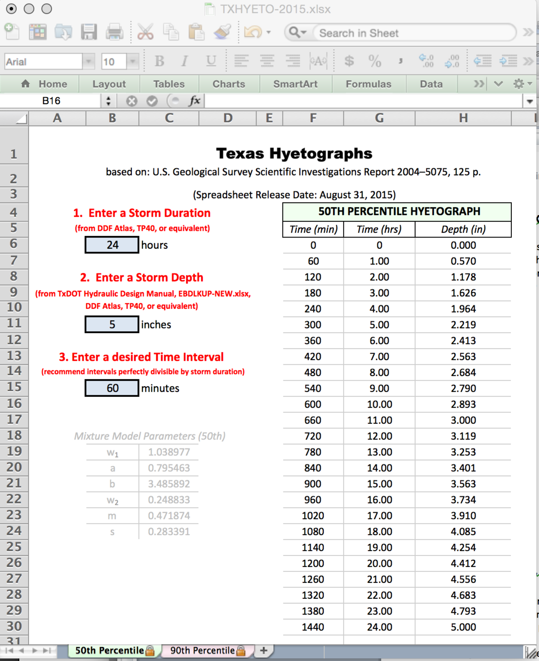

Figure 11. 25-YR, 24-HR TXHYETO-2015.xlsm Design Storm   
for Concho County, Texas.

Figure 11 is a screen capture of the design storm based on the TXHYETO-2015.xlsx worksheet for Concho Co., Texas. The peak discharge rate, in inches-per-hour is 0.608 inches/hour. The peak rate occurs at an elapsed time of 2 hours.

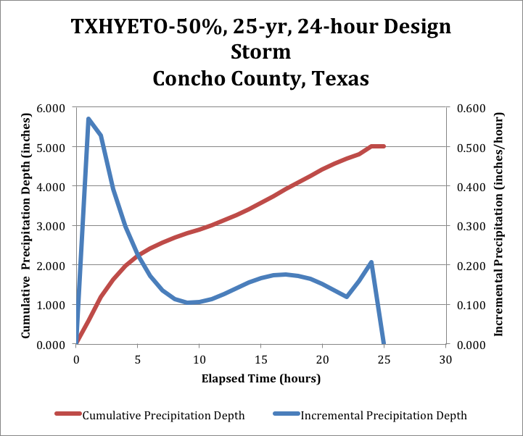

Figure 12. 25-YR, 24-HR Design Storm (TXHYETO-2015 50%) for Concho County, Texas.

Figure 12 is a screen capture of the design hyetograph based on the TXHYETO-2015.xlsx tool for Concho, Co., Texas.

### 25-YR, 6-HR SCS

The 25-yr, 6-hr SCS was also examined as one of the design storms to evaluate the US-87 crossing. The total storm depth was determined using the Texas DDF Atlas (CITE) for Concho County. Figure 13 is the relevant map from the DDF Atlas. Concho County is the yellow shaded area shown in Figure 13. The 25-yr, 6-hr storm depth from the map is about 4.1 inches.

The 6-hour SCS spreadsheet (Chow et. al. 1988) was used to generate a user-supplied hyetograph, based on the DDF Atlas storm depth.

Figure 14 is a screen capture of the spreadsheet tool with the 6-hr storm parameterized based upon the value in the DDF Atlas. The shaded area was added to accomplish the necessary dimensionalization (converting the dimensionless time and depth into dimensional time and depth). The check sums at the bottom of the shaded area are the total depth (actually in input value) and the maximum incremental depth reported into inches per hour.

The estimated intensity does not last for an entire hour, but is reported to provide some common comparison of input intensities for the different design storms.

Figure 15 is a plot of the SCS Storm for Concho County. The peak precipitation rate, in inches-per-hour is 2.96 inches/hour. The peak rate occurs at simulation time 2.28 hours.

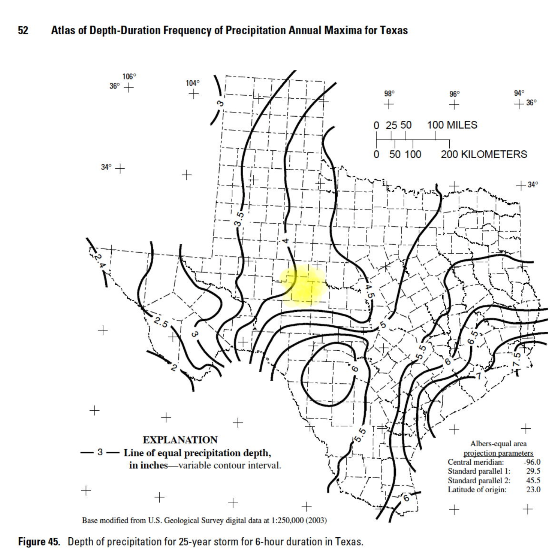

Figure 13. 25-YR, 6-HR Texas DDF Map. Concho County is the shaded area.

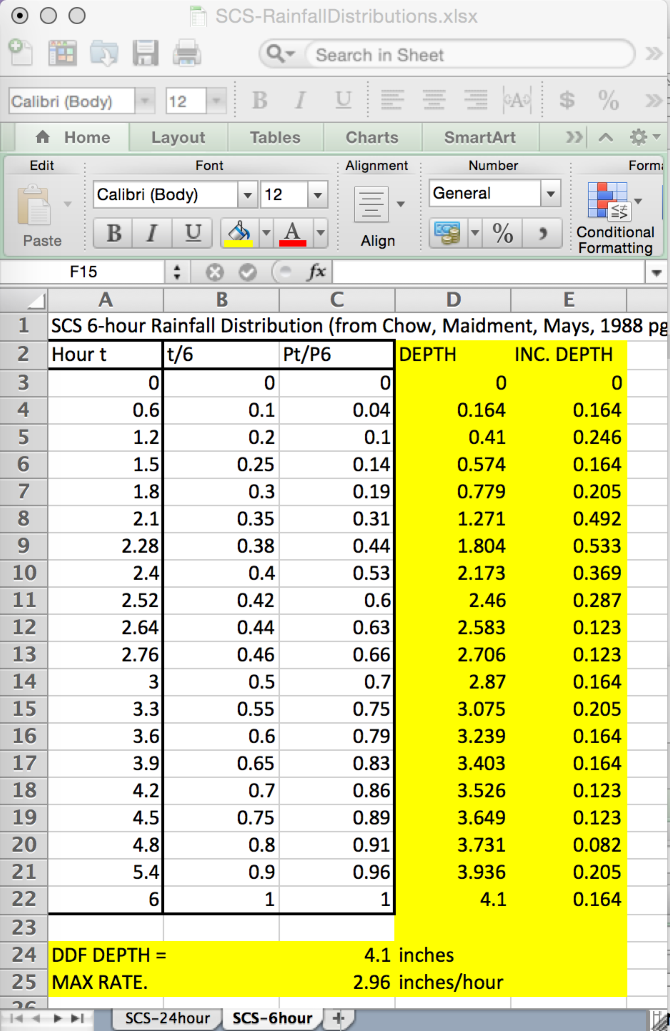

Figure 14. 25-YR, 6-HR SCS Design Storm for Concho County, Texas.

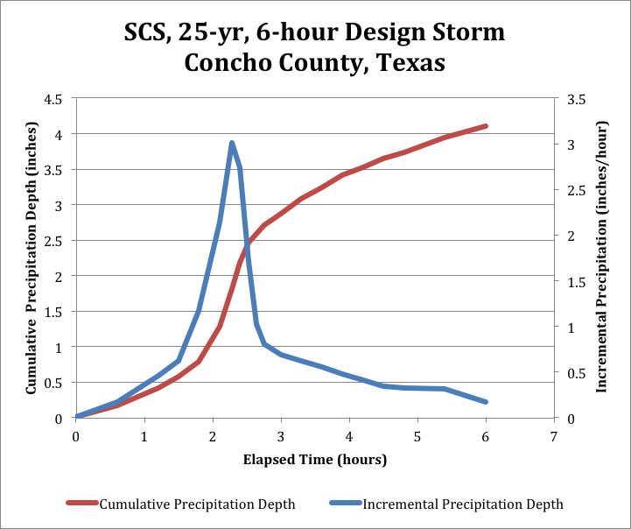

Figure 15. SCS 25-yr, 6-hr Design Storm for Concho County, Texas

### 25-YR, 6-HR TXHYETO(50%)

The 25-yr, 6-hr storm depth from the DDF Atlas was also used to parameterize the Texas Hydrograph. The 50th-percentile dimensionless hyetograph was chosen and parameterized for 20-minute time intervals for use in HEC-HMS as an additional design storm to evaluate the performance of the hydraulic structures.

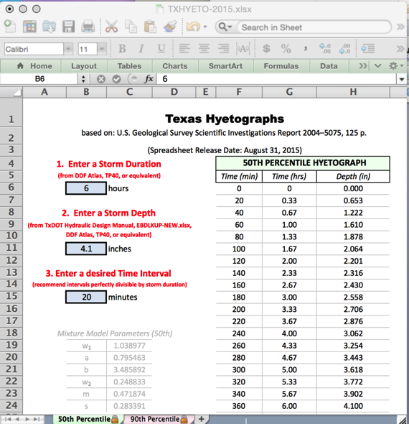

Figure 16. 25-YR, 6-HR TXHYETO-2015.xlsm Design Storm   
for Concho County, Texas.

Figure 16 is a screen capture of the TXHYETO-2015.xlsx worksheet for Concho Co., Texas.

Figure 17 is a screen capture of the design hyetograph based on the TXHYETO-2015.xlsx tool for Concho, Co., Texas. The peak discharge rate, in inches-per-hour is 1.44 inches/hour, and occurs at elapsed time 0.66 hours (40 minutes).

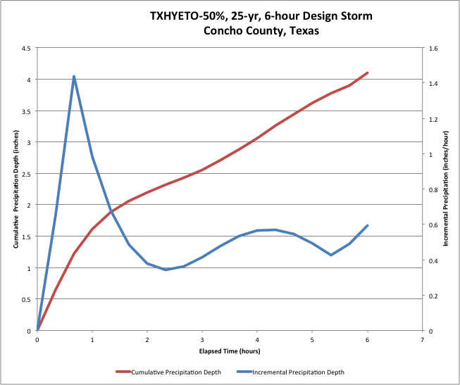

Figure 17. 25-YR, 6-HR Design Storm for Concho County, Texas.

# HEC-HMS CONCEPTUALIZATION

Figure 18 is the watershed base map with the HEC-HMS conceptualization overlain on the map. The entire watershed is conceptualized as being comprised of three sub-basins (North Catchment, West Catchment, and the Eden Catchment). The North Catchment drains into the North Reservoir; the West Catchment drains into the West reservoir; and the Eden Catchment drains directly into the US-87 Reservoir.[1]

The discharge from the North and West reservoirs is routed to the Junction depicted on the map. The distances, in feet of these routing elements are: West to Junction is XX.XX feet; North to Junction is XX.XX feet. The distance from the Junction to the US-87 reservoir is XX.XX feet.

The routing elements are conceptualized as channels with width and elevation determined directly from the topographic map. The routing technique employed is the Muskingum-Cunge method and the parameters are explained in subsequent portions of the report.

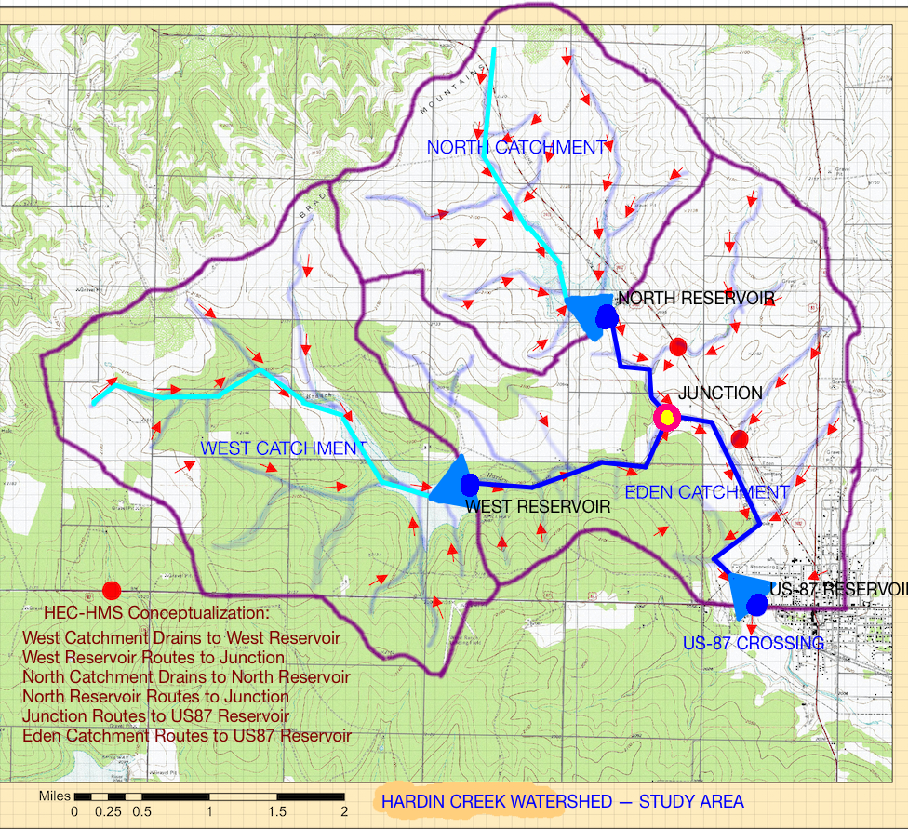

Figure 18. Hardin Creek Watershed with HEC-HMS Conceptualization Overlay

Figure 4 is a screen capture of the HEC-HMS interface showing the elements from Figure 3 in the HEC-HMS modeling environment.

The West, North, and Eden catchments all have a loss model and unit hydrograph associated with them. The SCS Curve Number loss model is used, and the SCS Dimensionless Unit Hydrograph is used for the watershed response. The remaining process models available in HEC-HMS are disabled in this study.

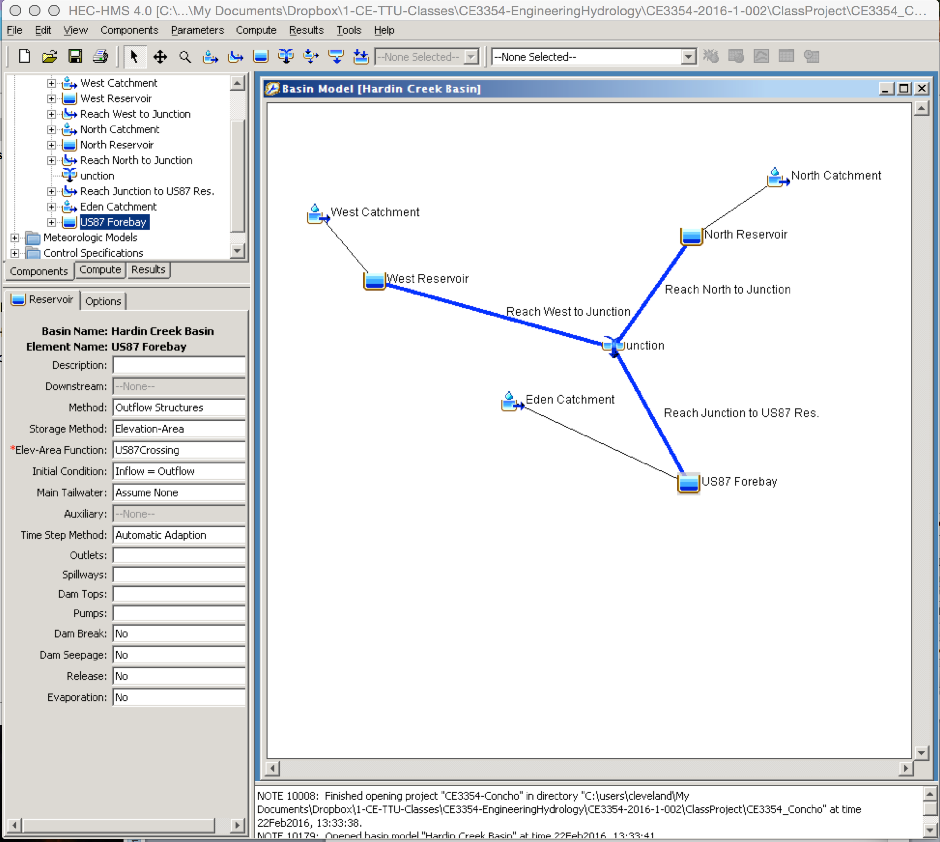

Figure 19. HEC-HMS Topology for Hardin Creek Study

## RAINFALL RUNOFF MODEL

The rainfall-runoff process selected was the SCS CN loss model, and the lumped parameter transformation model selected was the SCS Dimensionless Unit Hydrograph model. These two models were parameterized using the methods described in the following subsections.

### LOSS MODEL

The SCS CN was determined using the Web Soil Survey results described in the Watershed Description. To estimate a curve number, the hydrologic soil group type is identified, than based on land use and/or textural description the CN is estimated.

Approximate numerical ranges for transmission rates shown in the HSG definitions were first published by Musgrave (USDA 1955).

The four groups are:

1. Group A soils have low runoff potential and high infiltration rates of water transmission (greater than 0.30 in/hr).
2. Group B soils have moderate infiltration rates of water transmission (0.15- 0.30 in/hr).
3. Group C soils have low infiltration rates of water transmission (0.05-0.15 in/hr).
4. Group D soils have high runoff potential. These soils have a very low rate of water transmission (0-0.05 in/hr).

Based on the Ksat values from the Web Soil Survey results, the hydrologic soil groups for the study area are approximately 65% Group C and 35% Group D

The hydrologic condition of the study area is estimated to be GOOD. Figure 20 is an excerpt from the National Engineering Handbook relevant to the study area. The CN values for the 65% portion (Group C) of the study area is 74 and for the 35% portion (Group D) is 80.

The composite curve number for the three sub-catchments is computed using Equation 1 below:

${CN}_{comp.}=\left(0.65*74+0.35*80\right)=76$ (1)

The alternate *CN* is determined using the area weighted Ksat of 0.08 inches/hour would place the entire study area as Group C soil, and the resulting value from Figure 20 is 74. The difference between the two values at the scale of the study is irrelevant; however we choose to use the larger of the two values (76) to challenge the hydraulic structure.

The Eden Catchment value was increased by considering the roughly 14% of developed area within the catchment. Its value was computed using Equation 2 below:

${CN}_{Eden}=\left(0.86*76+0.14*98\right)=79$ (2)

The composite CN for each sub-basin is listed in Table 4.

Table 4. CAPTION THE TABLE

|  |  |  |  |
| --- | --- | --- | --- |
| Sub-basin name | Area (sq. mi.) | Composite CN | Remarks |
| North Catchment | 3.83 | 76 | Used larger value |
| West Catchment | 6.04 | 76 | Used larger value |
| Eden Catchment | 6.95 | 79 | Reflect the developed portion. |

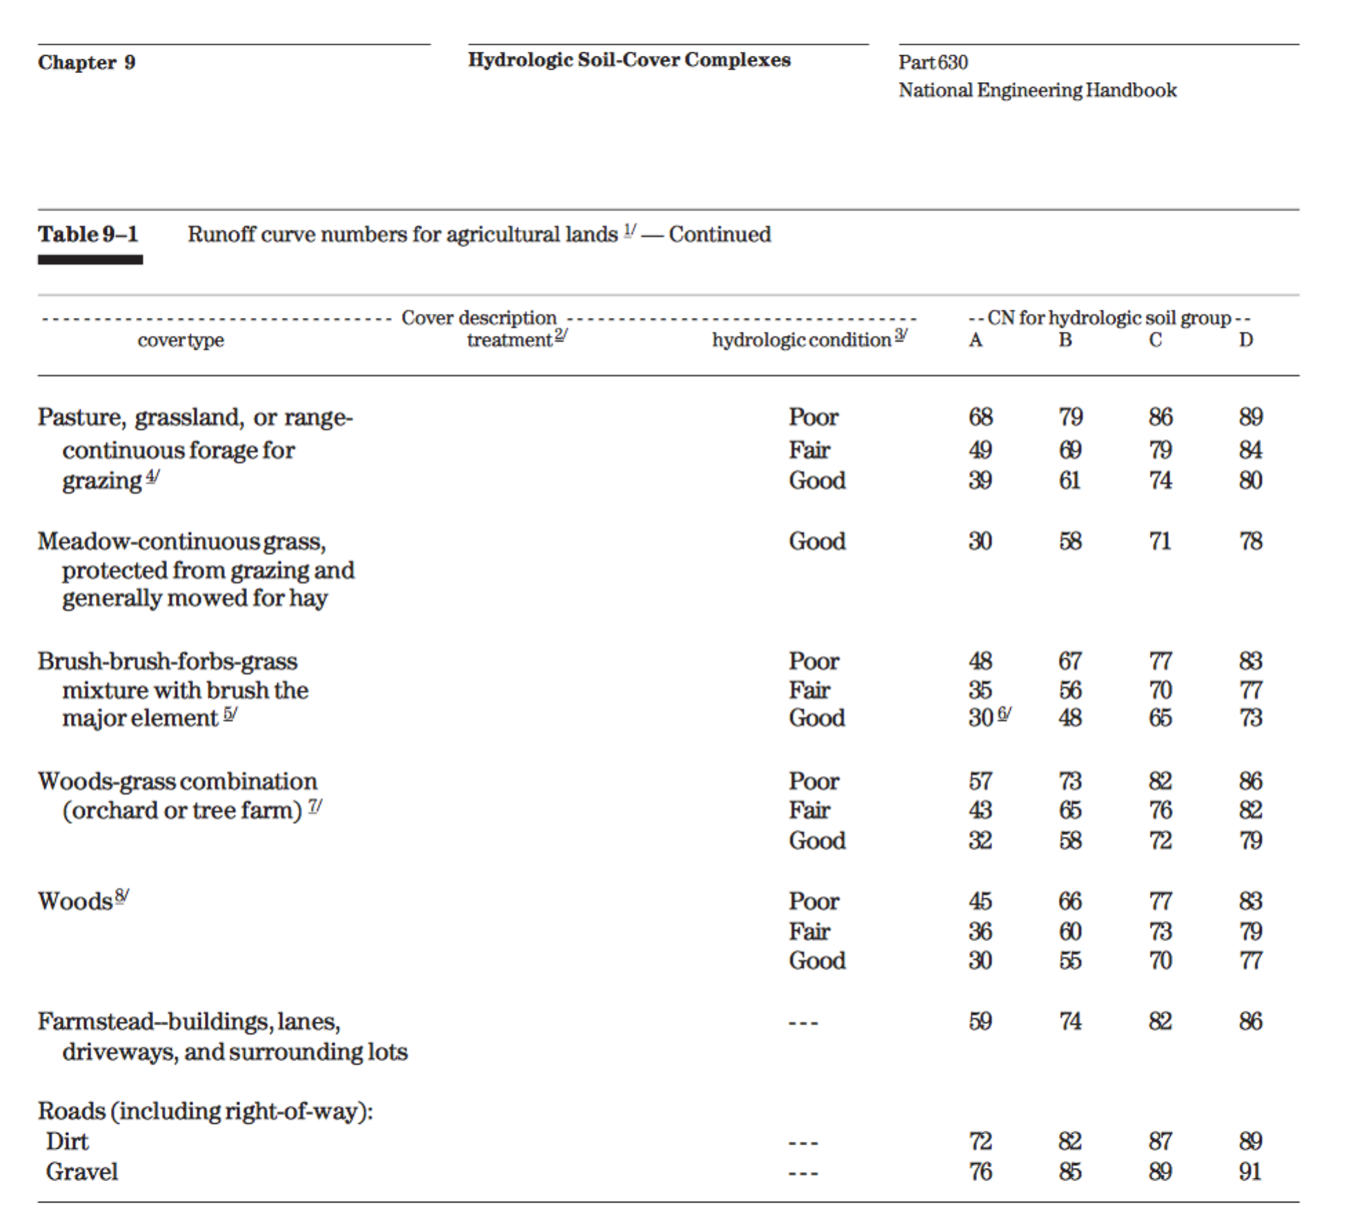

Figure 20. CN Table from NEH Part 630 , Chapter 9

### UNIT HYDROGRAPH MODEL

The SCS DUH was parameterized for each sub-basin <list their names here> using the NRCS overland method for different cover types. The <tool name .xlsm> (CITE SOURCE) was used to estimate the travel times for runoff in each of the three catchments.

Figure 16 is a screen capture of the analysis for the West Catchment.

<Add analysis notes as necessary to maintain clarity and flow of report>



Figure 21. NRCS lag time analysis for West Catchment.

Figure 17 is a screen capture of the analysis for the North Catchment.



Figure 22. NRCS lag time analysis for North Catchment.

Figure 18 is a screen capture of the analysis for the Eden Catchment.



Figure 23. NRCS lag time analysis for Eden Catchment.

<Table 4 is a list of …>.

Table 5. CAPTION THE TABLE

|  |  |  |
| --- | --- | --- |
| Sub-basin name | Area (sq. mi.) | Lag Time (for DUH) |
| North Catchment | 3.83 |  |
| West Catchment | 6.04 |  |
| Eden Catchment | 6.95 |  |

## HYDROGRAPH ROUTING ELEMENTS

Discharge leaving the West and North Reservoirs are routed through a stream system to the US-Reservoir.

### CHANNEL ELEMENTS

The channels are modeled as 8-point cross sections and the Muskingum-Cunge routing model is used (CITE HEC-HMS PAGES). The three channel sections are <name the 3 sections>.

Values of Manning’s n appropriate for the channel sections was chosen from Appendix I (Table 8.2 CITE SOURCE).



Figure 24. Typical Cross Section for <name 1>.

Section <name 1> is shown on Figure XX. <describe the channel coverage, grass lined, etc.> Manning’s n for the section is ##. The average channel slope is X.XXXX. The length of the channel is XXXX feet.



Figure 25. Typical Cross Section for <name 2>.

Section <name 2> is shown on Figure XX. <describe the channel coverage, grass lined, etc.> Manning’s n for the section is ##. The average channel slope is X.XXXX. The length of the channel is XXXX feet.



Figure 26. Typical Cross Section for <name 3>.

Section <name 3> is shown on Figure XX. <describe the channel coverage, grass lined, etc.> Manning’s n for the section is ##. The average channel slope is X.XXXX. The length of the channel is XXXX feet.

## RESERVOIR STORAGE ELEMENTS

The West and North Reservoirs are <describe the reservoirs – the dam crest height, the spillway height, and the riser pipe height>

The reservoirs are assumed to already contain water at pool elevation equal to the outlet riser pipe – thus any additional water added to the reservoir will immediately raise the pool elevation above the riser pipe and water will begin to flow out of the reservoir into the drainage channels.

Figure XX is an elevation view (not to scale) sketch of the West and North reservoirs.

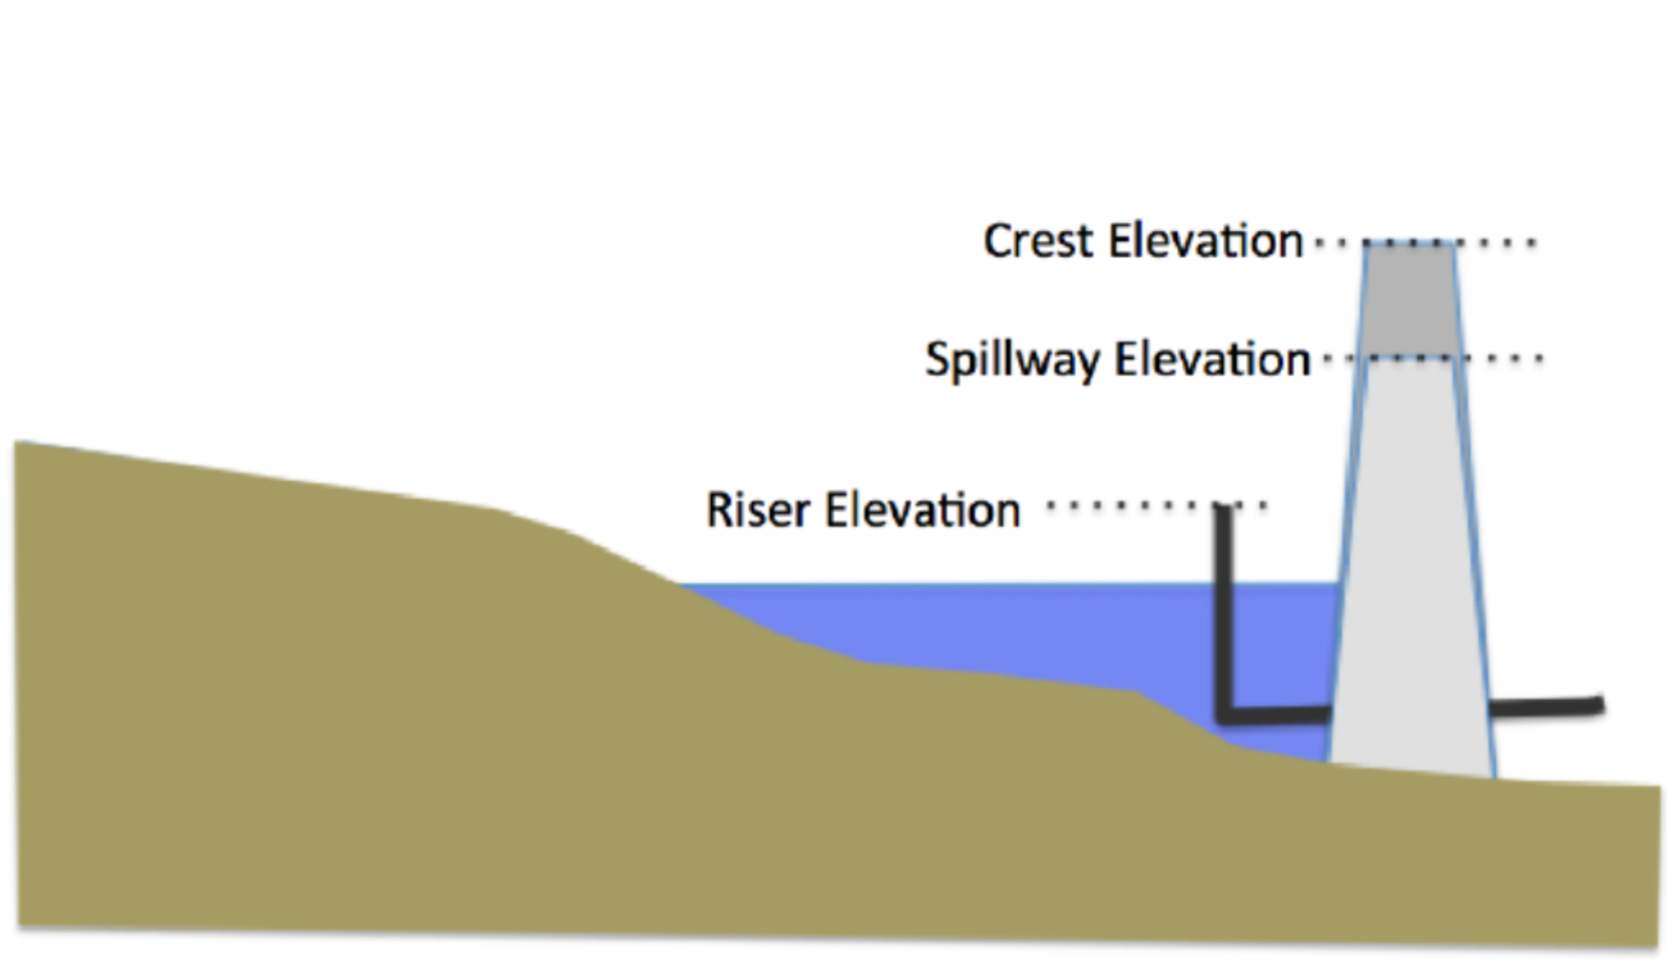

Figure 27. CAPTION THE FIGURE

### NORTH RESERVOIR ELEVATION-AREA-STORAGE TABLE

<describe the elevation-area calculations Lectures 19 and 20>

<Show representative calculations/measurements>

<can assume spillways are 50 ft wide and dam crest height is 4 feet above spillway crest>

<report riser elevation, crest elevation, and spillway elevation>

<Then provide the table>

### WEST RESERVOIR ELEVATION-AREA-STORAGE TABLE

<describe the elevation-area calculations Lectures 19 and 20>

<Show representative calculations/measurements>

<can assume spillways are 50 ft wide and dam crest height is 4 feet above spillway crest>

<report riser elevation, crest elevation, and spillway elevation>

<Then provide the table>

### US-87 RESERVOIR ELEVATION-AREA-STORAGE TABLE

<Make a similar sketch to Figure 23, except the riser is a horizontal culvert. The spillway elevation is the roadway height>

Figure XX is an profile view looking downstream at the US-87 Crossing (US-87 Reservoir Outlet). The road profile is the grey region that slopes down to the top of the culverts then back up. The original stream channel is shown – there is sufficient space to add additional culvert barrels if indicated. The dashed line approximates the spillway/crest profile (the approximation is for simplicity in hydraulics calculations).

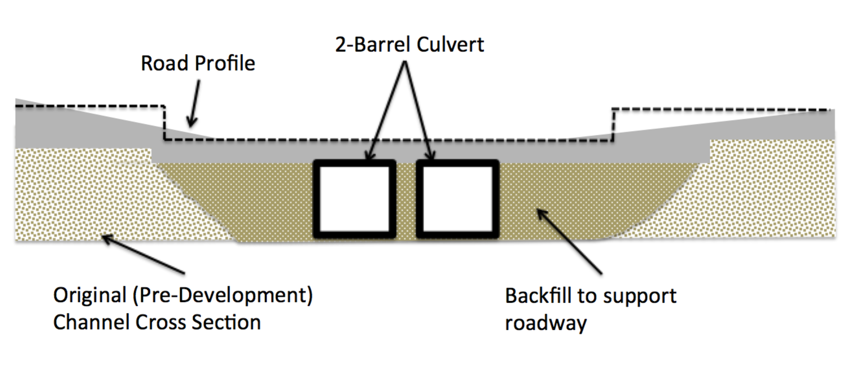

Figure 28. CAPTION THE FIGURE

<describe the elevation-area calculations Lectures 19 and 20>

<Show representative calculations/measurements>

<Use google earth to approximate spillway width. Assume dam crest height is 1.0 feet above spillway>

<report culvert bottom, crest elevation, and spillway elevation>

<Then provide the table>

# 

Figure 29. CAPTION THE FIGURE

<describe the elevation-area calculations Lectures 19 and 20>

<Show representative calculations/measurements>

<Use google earth to approximate spillway width. Assume dam crest height is 1.0 feet above spillway>

<report culvert bottom, crest elevation, and spillway elevation>

<Then provide the table>

## DISCHARGE ESTIMATES

Add Narrative Here – Naturally you need to run the model(s).

## PEAK WATER SURFACE ELEVATION

Add Narrative Here – Naturally you need to run the model(s).

You get peak elevation from where? (which reservoir)

### EXISTING CONDITION

Add Narrative Here – Naturally you need to run the model(s) .

Peak WSE for 4 design storms. Does the reservoir overtop (ie does the elevation go above the spillway?)

### PROPOSED CONDITION

Add Narrative Here – Naturally you need to run the model(s) .

Peak WSE for 4 design storms. Does the reservoir overtop (ie does the elevation go above the spillway?)

# INTERPRETATION OF RESULTS

Add Narrative Here – Naturally you need to run the model(s) .

Don't forget you have to do the 100-yr check flood (I would adjust the worst case storm to equal a 100 year depth for the requisite duration and re-run just that simulation.

# SUMMARY, CONCLUSIONS, AND RECOMMENDATIONS

Add Narrative Here – Naturally you have to write this section after nearly everything else is completed.

# REFERENCES

Asquith, W.H., and Roussel, M.C., 2004, Atlas of depth-duration frequency of precipitation annual maxima for Texas: U.S. Geological Survey Scientific Investigations Report 2004–5041, 106 p.

Soil Conservation Service, 1973, A method for estimating volume and rate of runoff in small watersheds: Washington, D.C., U.S. Department of Agriculture, Soil Conservation Service, SCS–TP–149, 19 p.

Chow, V.T., Maidment, D.R., and Mays, L.W., 1988, Applied hydrology: New York, McGraw-Hill Publishing Company, 572 p.

HEC-HMS, 2015. Hydrologic Modeling System HEC-HMS. U.S. Army Corps of Engineers, Hydrologic Engineering Center (CEIWR-HEC) http://www.hec.usace.army.mil/software/

hec-hms/; accessed date.

McCuen, R. H., 1989. Hydrologic Analysis and Design, 2ed. Prentice Hall, 814 p.

Musgrave, G.W. 1955. How much of the rain enters the soil? *In* Water: U.S. Department of Agriculture. Yearbook. Washington, DC. pp. 151–159.

TxDOT 2015. Hydraulic Design Manual, Texas Department of Transportation, http://onlinemanuals.txdot.gov/txdotmanuals/hyd/index.htm; accessed March 19, 2016.

Texas Department of Transportation, Statewide Planning Map. http://www.txdot.gov/

apps/statewide_mapping/StatewidePlanningMap.html; accessed March 19, 2016.

Neale, C.M., Tay, C.C., Herrmann, G.R., and Cleveland, T.G. 2015. "TXHYETO.XLS a tool to facilitate use of Texas-Specific Hyetographs for design storm modeling." Proceedings of ASCE World Environmental and Water Resources Congress, ASCE-EWRI, Austin, TX. May 17-21, 2015. pp. 241-254.

NRCS Overland Method – find it, cite the NRCS document. Also cite the URL for the Spreadsheet Tool (if you use it). If you use Kerby-Kirpich, cite the source document (its not my notes!) and the spreadsheet tool if you use it (cite the uRL).

USAF 1985. Search and Rescue Survival Training, AF REGULATION 64-4

VOLUME I. 579 p.

USDA-NRCS, 2016. Web Soil Survey. http://websoilsurvey.sc.egov.usda.gov/App/

WebSoilSurvey.aspx ; accessed March 19, 2016

# APPENDIX-I MANNING’S N VALUES

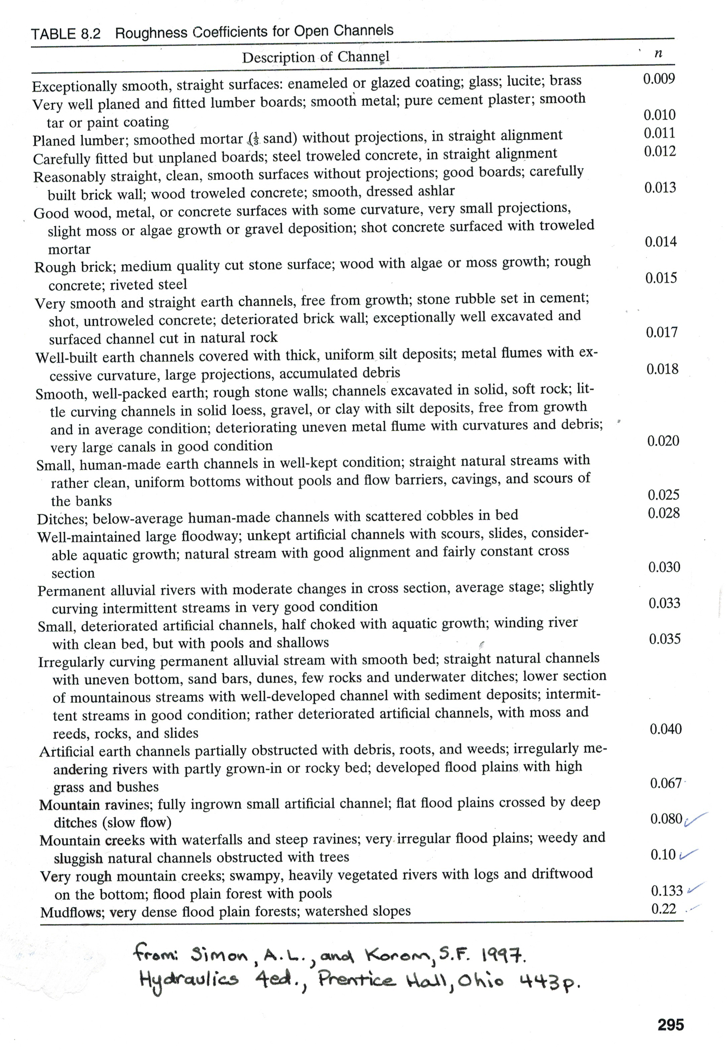

# APPENDIX-II HEC-HMS Support Files (Excel Spreadsheets)

1. The crossing hydraulic structure is modeled as a reservoir with 2 or 4 culvert outlets and an overflow spillway.